# Computer Vision Hw5 Report

* Discription
  + Mathematical Morphology – Gray Scaled Morphology
* Algorithm
  + Kernel of dilation, erosion, opening and closing

Value = 0

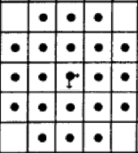

* Parameters (if any)
  + no
* Principal Code Fragment

Main

(file – /src/hw5/ DemoGrayLevelMorphology.java)

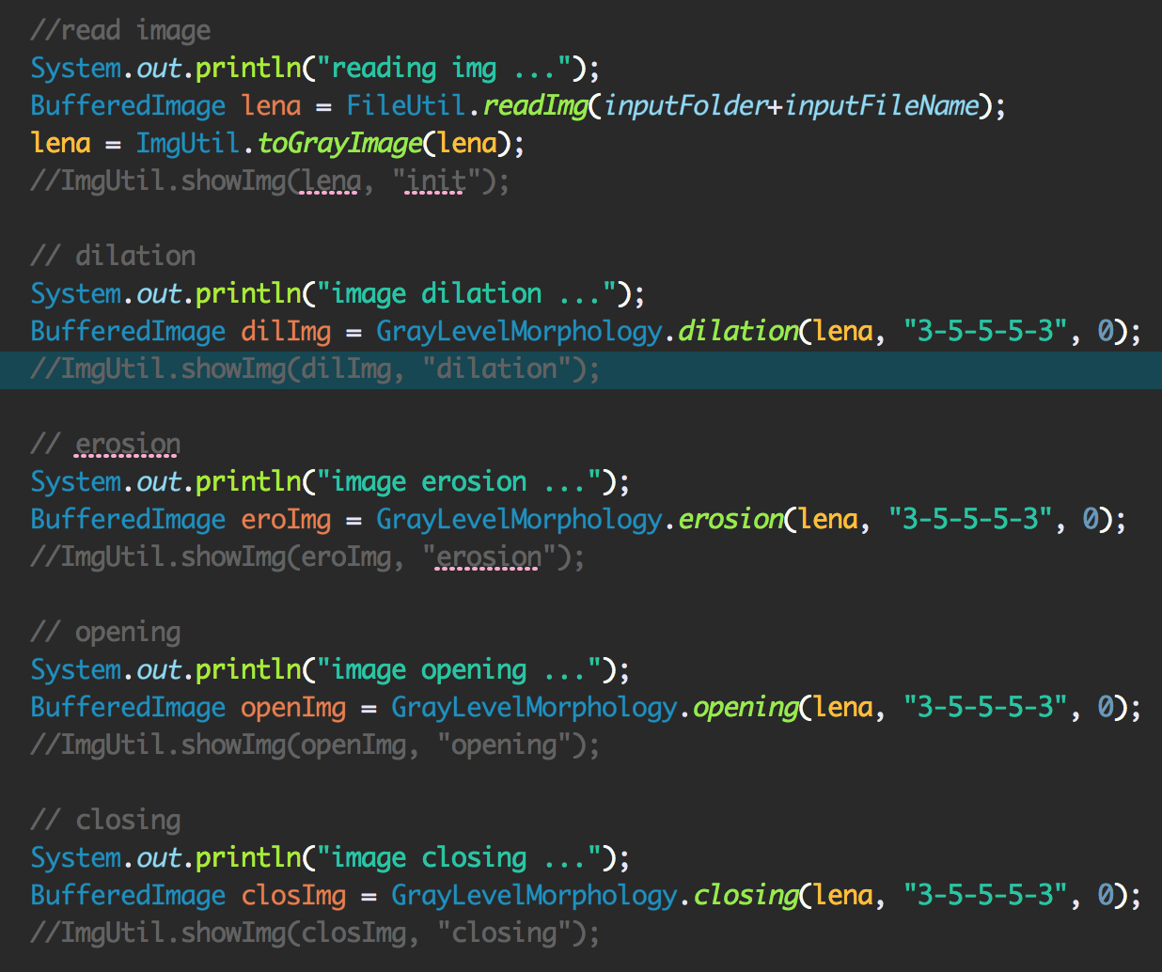

Dilation

(file – /src/cv1.util.cv / GrayLevelMorphology.java)

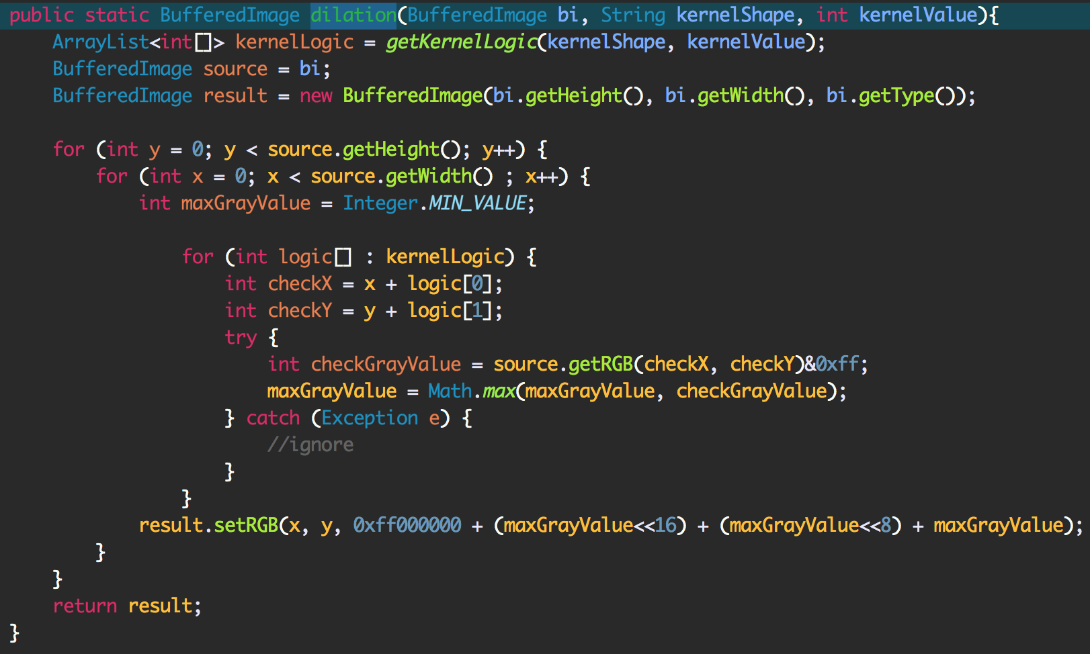

Erosion

(file – /src/cv1.util.cv / GrayLevelMorphology.java)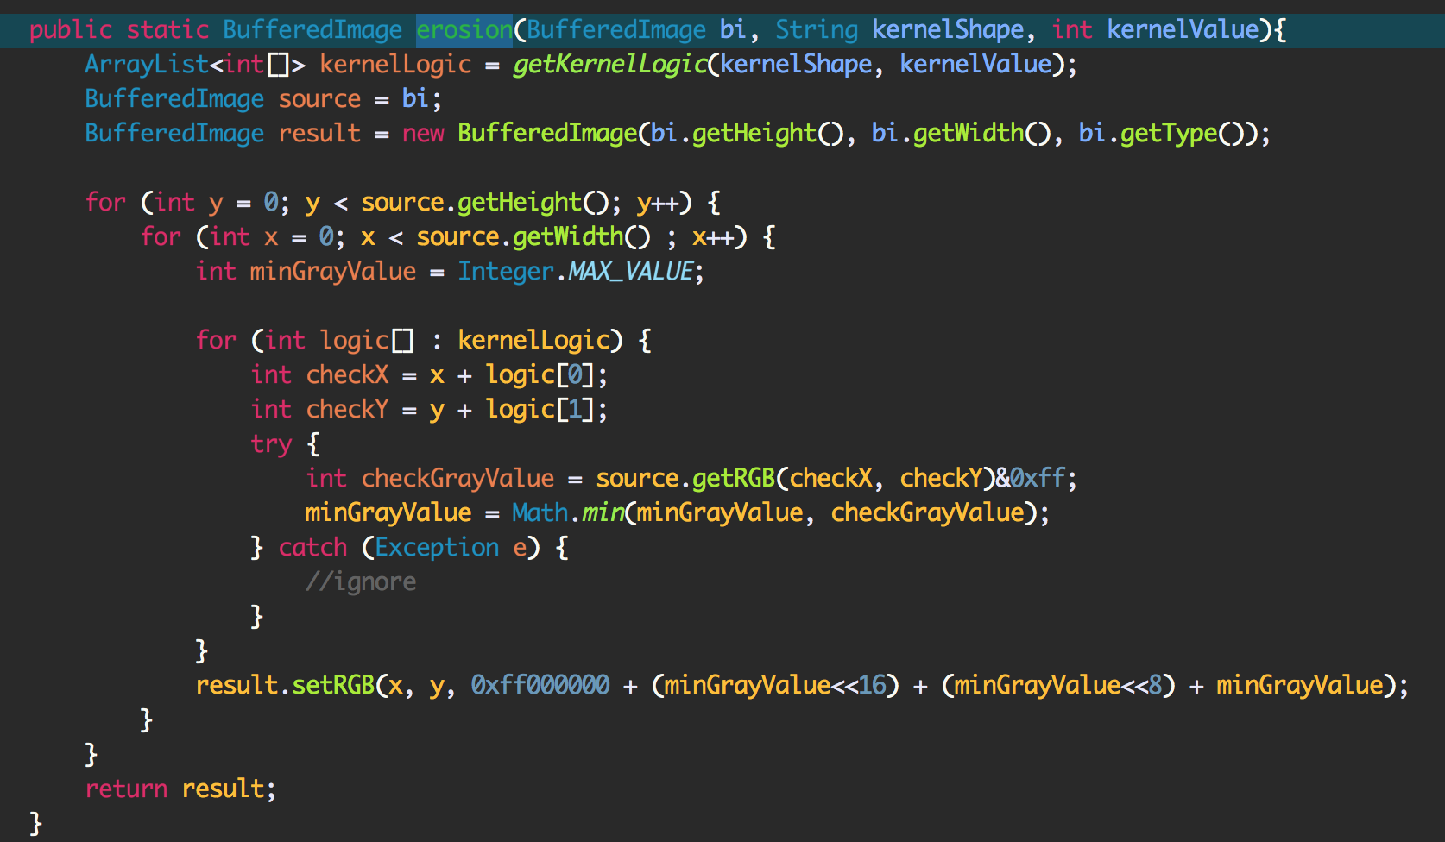

Opening and Closing

(file – /src/cv1.util.cv / GrayLevelMorphology.java)

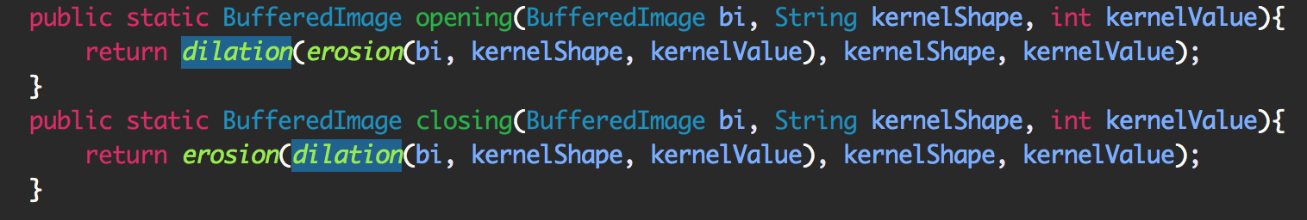

* Result Image

Dilation Erosion

 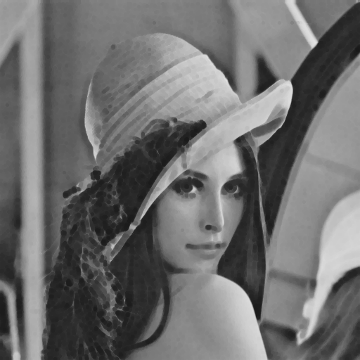

Opening Closing

